- Create a virtual environment to run it
python -m venv venv
\venv\Scripts\Activate.ps1

- Install dependencies and modules
pip install flask-cors {for connecting frontend to backend}
-m pip install -r requirements.txt
- Database management:

Create a database “user_db” with a table called “project_submissions” using the following command:
mysql>create database user_db;
mysql>use user_db;
mysql> CREATE TABLE project_submissions (
-> id INT AUTO_INCREMENT PRIMARY KEY,
-> name VARCHAR(100) NOT NULL,
-> email VARCHAR(100) NOT NULL,
-> phone VARCHAR(20),
-> vehicle_year INT,
-> vehicle_make VARCHAR(50),
-> vehicle_model VARCHAR(50),
-> project_description TEXT,
-> submitted_at TIMESTAMP DEFAULT CURRENT_TIMESTAMP
-> );
in app.py, make sure to input the correct mysql user, password and database name
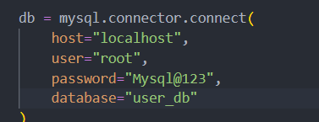

Now run the python app in the virtual environment
python app.py
Run the frontend too by opening a new powershell terminal and running
“npm start”

